INTRODUCTION TO AZURE AND IAM
Agenda
- Introduction to Microsoft Azure
- Difference between Azure and AWS
- Terminologies
- IAM
  - Users
  - Groups
  - Roles
  - Policies
Introduction to Microsoft Azure:
Microsoft Azure is a cloud computing platform and service offered by Microsoft. It provides a broad set of cloud services that help businesses and individuals build, deploy, and manage applications and services on a global scale. Azure offers Infrastructure as a Service (IaaS), Platform as a Service (PaaS), and Software as a Service (SaaS), making it a versatile and scalable cloud solution.
Azure as a Cloud Platform:
Azure provides a global cloud infrastructure that allows businesses to host applications, store data, and process workloads efficiently. It is highly scalable, secure, and cost-effective, making it a popular choice for businesses of all sizes.
Azure supports hybrid cloud, allowing businesses to connect their on-premises data centers with Azure cloud services seamlessly. This hybrid approach ensures better control, compliance, and flexibility for enterprises.
Difference between Azure and AWS:
- Integration with Microsoft Products – Azure provides seamless integration with Microsoft tools like Windows Server, Active Directory, Office 365, and SQL Server, making it ideal for enterprises using Microsoft ecosystems. AWS supports Windows but requires additional configurations.
- Hybrid Cloud Capabilities – Azure has stronger hybrid cloud support with Azure Arc and Azure Stack, allowing businesses to integrate on-premises infrastructure with the cloud. AWS offers AWS Outposts, but Azure provides deeper hybrid integration.
- Virtual Machines (VMs) & Compute Services – AWS uses Elastic Compute Cloud (EC2), which provides more instance types and flexible pricing. Azure provides Virtual Machines (VMs) with better Windows-based optimization.
- Networking & Connectivity – Azure uses Virtual Network (VNet) for private networking, while AWS uses Virtual Private Cloud (VPC). AWS has a more mature networking infrastructure with better global reach.
- Storage Solutions – AWS offers Simple Storage Service (S3), which is widely adopted and highly scalable. Azure provides Blob Storage, which integrates better with Windows-based applications but is less popular than S3.
- AI & Machine Learning Services – Azure offers Azure Cognitive Services and Azure Machine Learning, focusing on AI-powered applications. AWS has AWS SageMaker, which is more developer-friendly for custom machine learning models.
- Serverless Computing – AWS Lambda is the most widely used serverless computing solution. Azure Functions offers similar functionality but integrates more naturally with Microsoft environments.
- Security & Identity Management – Azure provides Azure Active Directory (Azure AD) for identity management, making it more enterprise-friendly. AWS uses AWS IAM (Identity and Access Management), which is more flexible but requires additional setup.
- Big Data & Analytics – AWS offers Redshift, EMR, and Athena for big data and analytics, making it ideal for data-heavy workloads. Azure provides Azure Synapse Analytics, which integrates well with Microsoft BI tools.
- Pricing & Cost Optimization – AWS offers better pay-as-you-go pricing and a more extensive free tier. Azure provides cost benefits for businesses already using Microsoft licenses (Azure Hybrid Benefit).
Setup of Microsoft Azure:
Step 1: Go to the link below and open the official website of Microsoft Azure.
Microsoft Azure Link
Step 2: Select Try Azure for free and then enter email address and set the password, then enter the details asked.
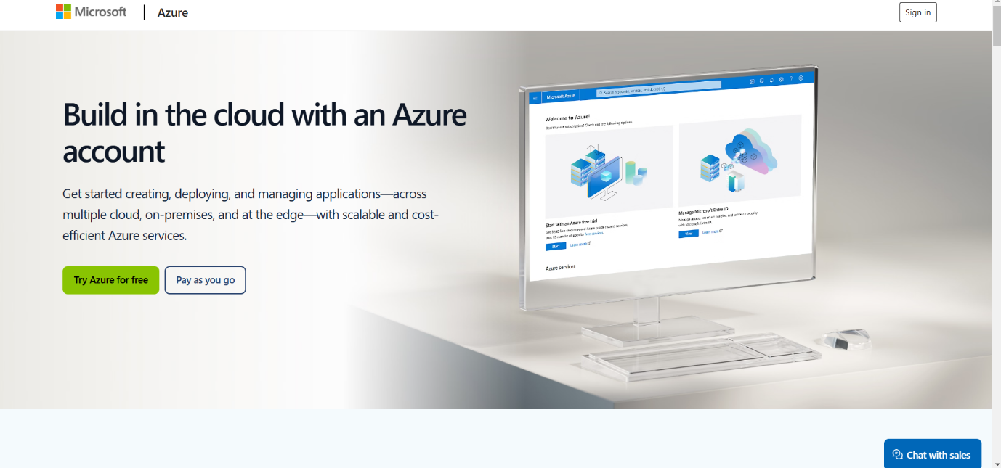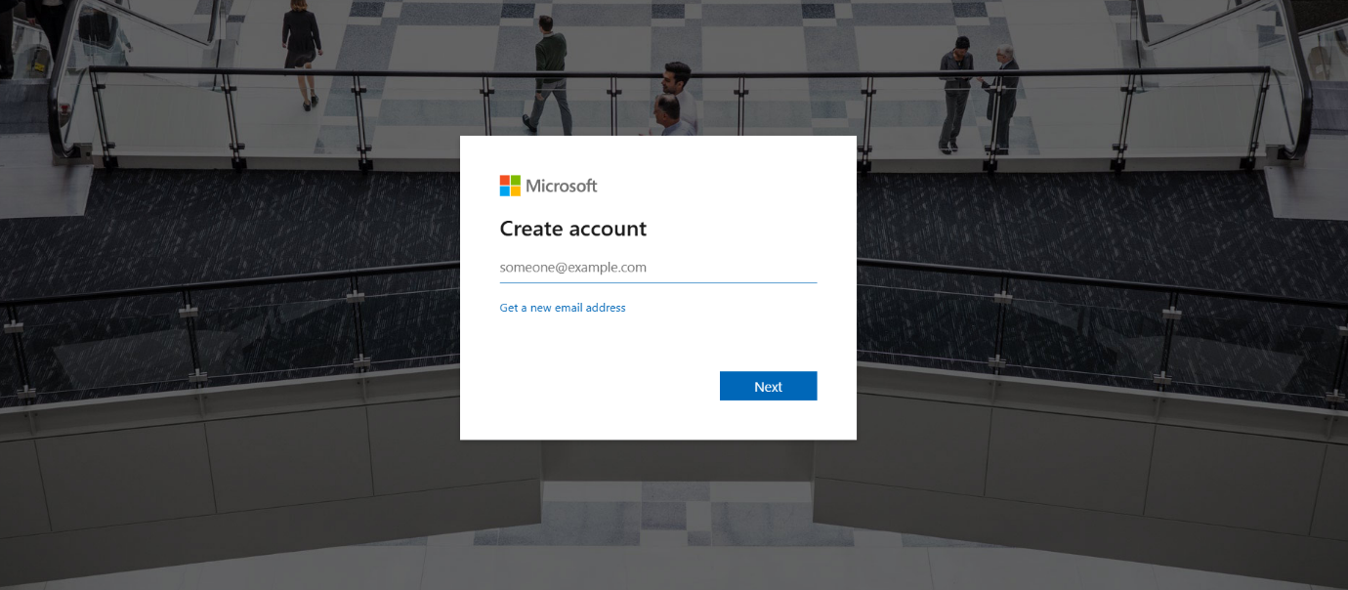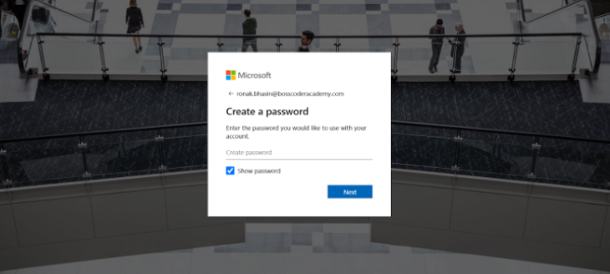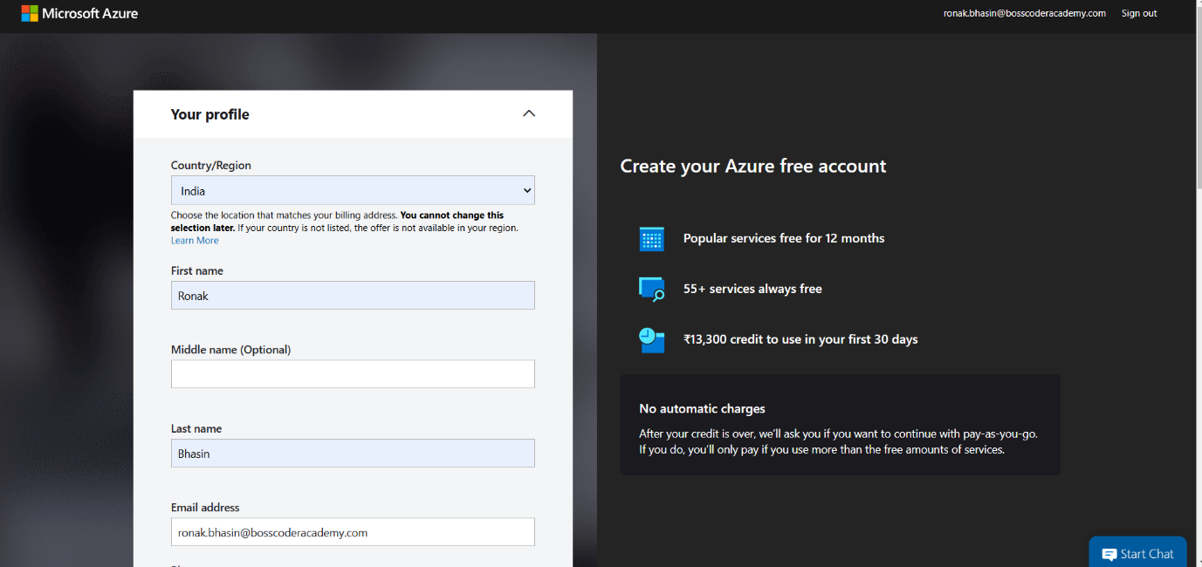
Step 3: Enter the details of the Card Holder.
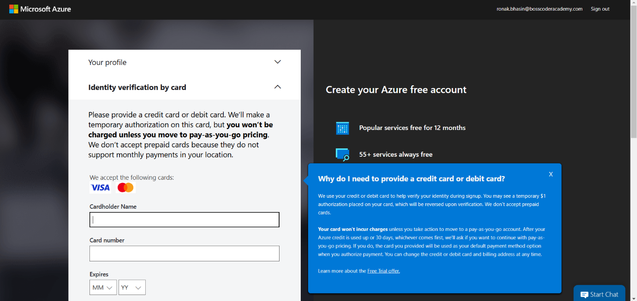
Step 4: Then, the Homescreen of Microsoft Azure will come and you can select the service and work upon that.
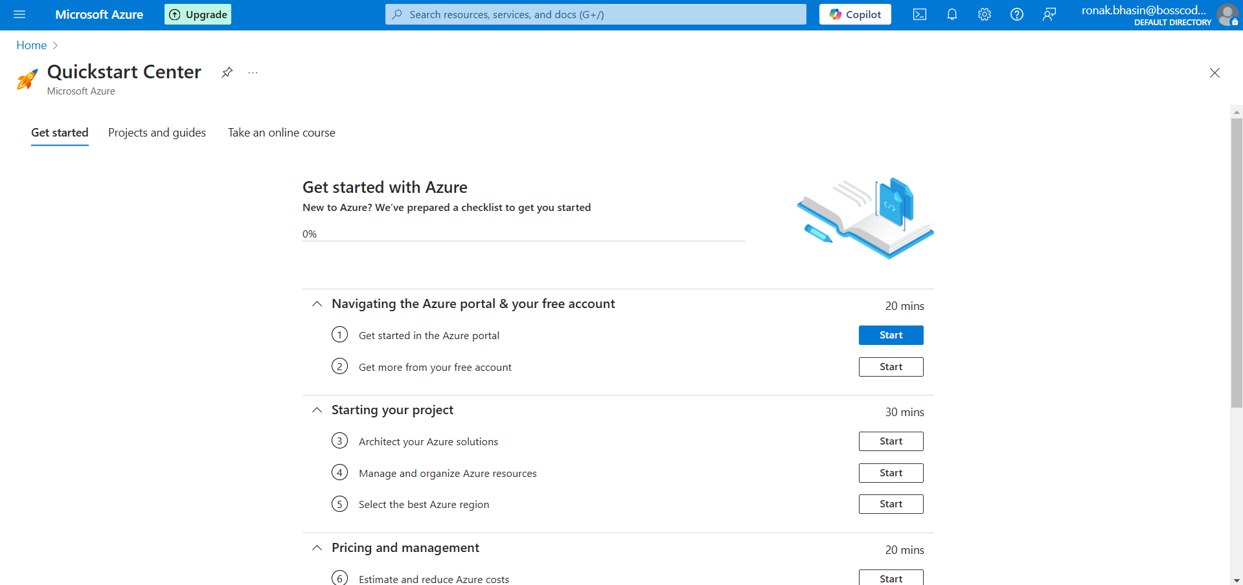
Terminologies:
1. Root User:
- The Root User in Azure is the Account Administrator who has complete access to all Azure resources and subscriptions.
- It is created when you sign up for an Azure account and has the highest level of control.
Steps to Implement:
Step 1: Sign up for Azure at portal.azure.com.
Step 2: The account used to register becomes the Root User (Account Administrator).
Step 3: Use this account to create subscriptions, manage permissions, and oversee billing.
NOTE: It is the same as the setup of Microsoft Azure.
2. Management Groups:
- Management Groups are used to organize multiple Azure subscriptions under a single structure.
- They help in applying policies and access controls at a higher level than subscriptions.
Steps to Implement:
Step 1: Go to Azure Portal → Search for Management Groups.
Step 2: Click Create Management Group and then Create Management Group.
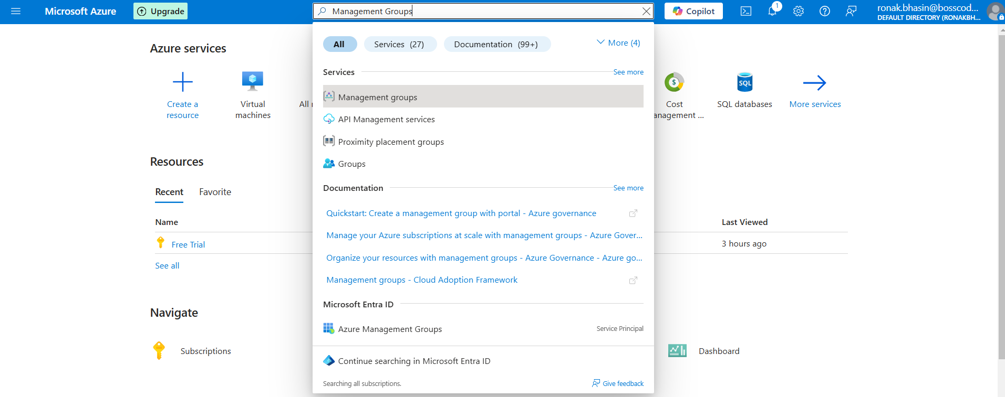
Step 3: Provide a Group ID and Group Name.
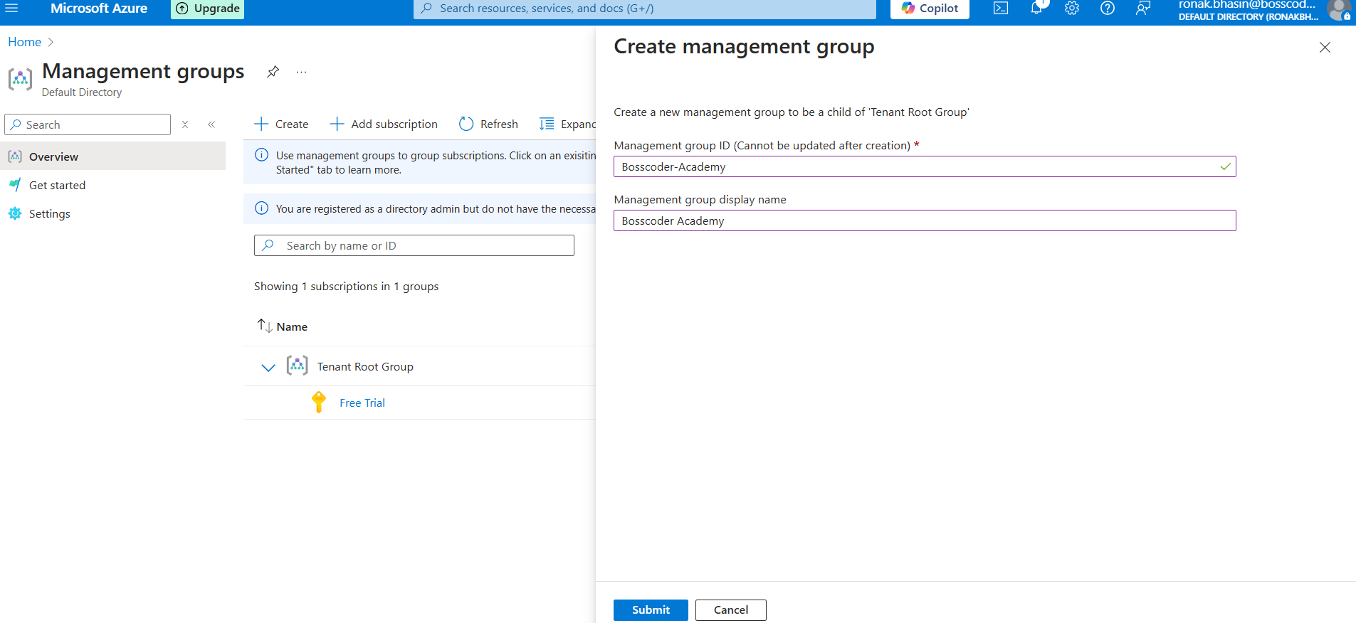
Step 4: Add subscriptions under the management group.
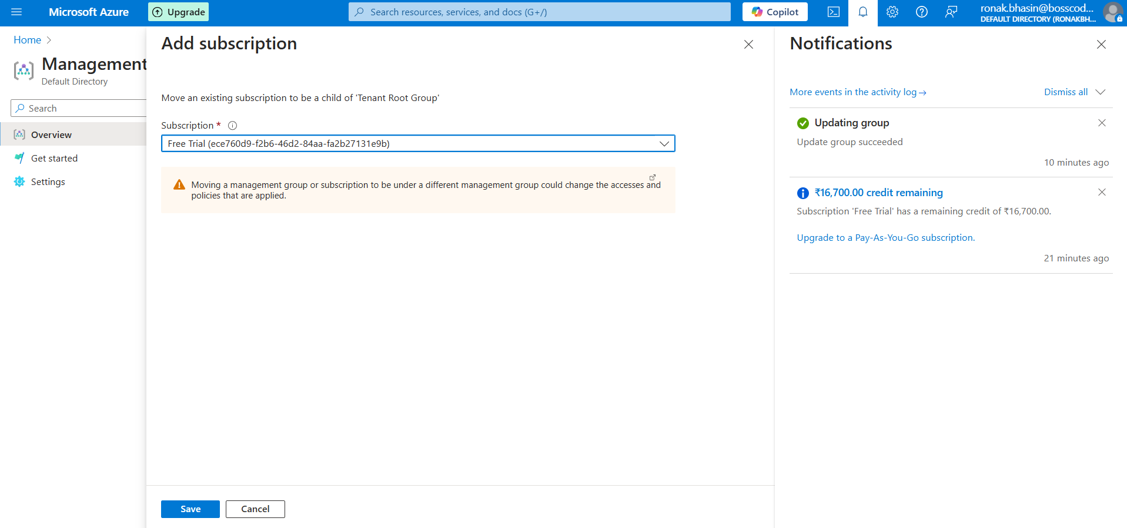
Step 5: Assign RBAC (Role-Based Access Control) roles or policies as per your requirement.
NOTE: For IAM roles also, this method is followed which will be taught later.
3. Subscriptions:
- A Subscription is a container that holds Azure resources and links them to a billing account.
- Each subscription has unique billing, resource limits, and policies.
Steps to Implement:
Step 1: Sign in to Azure Portal.
Step 2: Go to Subscriptions → Click Add.
Step 3: Select a Subscription Offer (like Pay-As-You-Go, Free Trial).
Step 4: Add Billing Information and confirm the creation.
Step 5: Assign roles and policies as needed.
4. Resources:
- Resources are individual services in Azure like Virtual Machines, Databases, Storage, Networking components.
- They exist inside Resource Groups.
An example of a resource we are taking is a virtual machine.
Steps to Implement:
Step 1: Navigate to Azure Portal.
Step 2: Select the desired service (e.g., Virtual Machine, Storage Account).
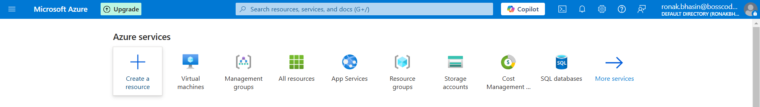
Step 3: Click Create, provide required details, and assign it to a Resource Group.
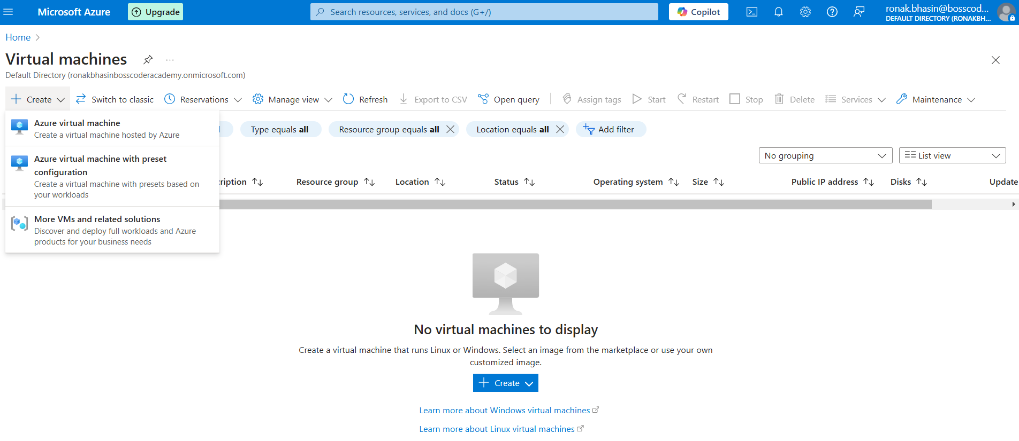
Step 4: Configure networking, security, and other settings.
Step 5: Click Deploy.
5. Resource Groups:
- A Resource Group is a logical container that holds multiple Azure resources.
- It helps in organizing and managing resources efficiently.
Steps to Implement:
Step 1: Open Azure Portal → Go to Resource Groups.
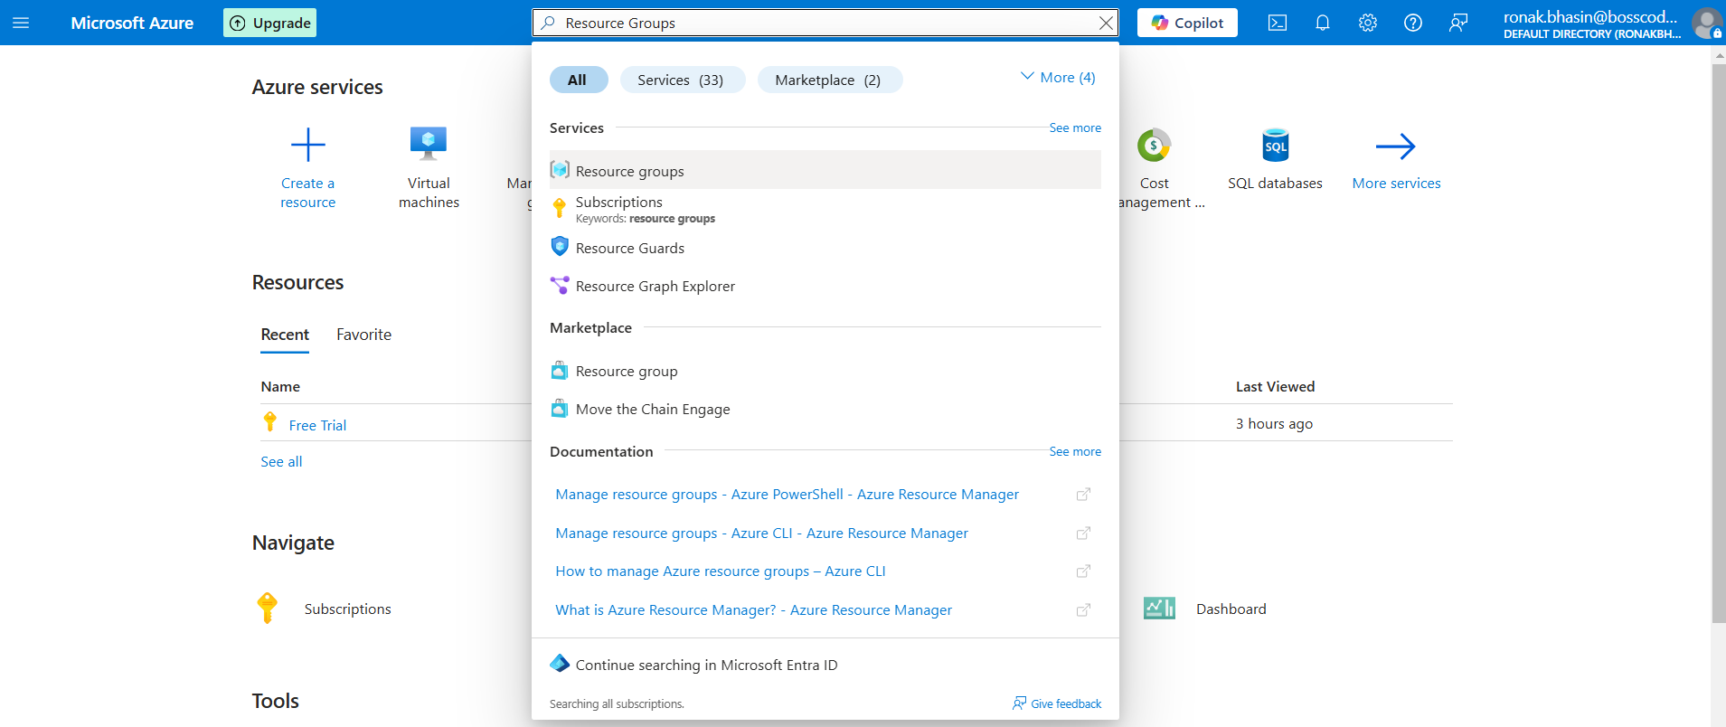
Step 2: Click Create Resource Group.
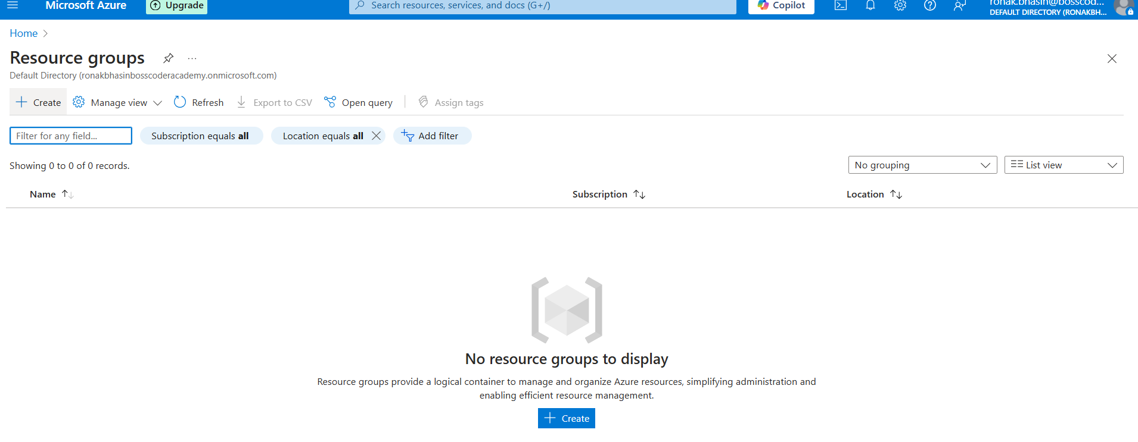
Step 3: Enter a Name and choose a Region.
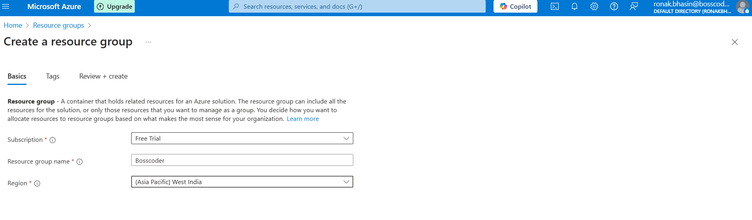
Step 4: Add Azure resources to this group as per your choice.
NOTE: We have not added any resources.
Step 5: Now, click on Create and a resource group is created and then after clicking on it you can add Resources to this Resource Group.
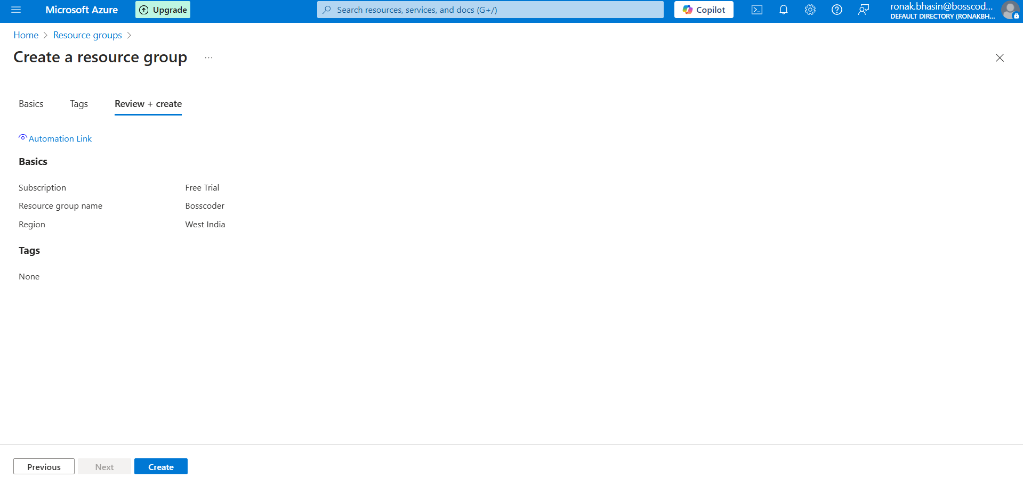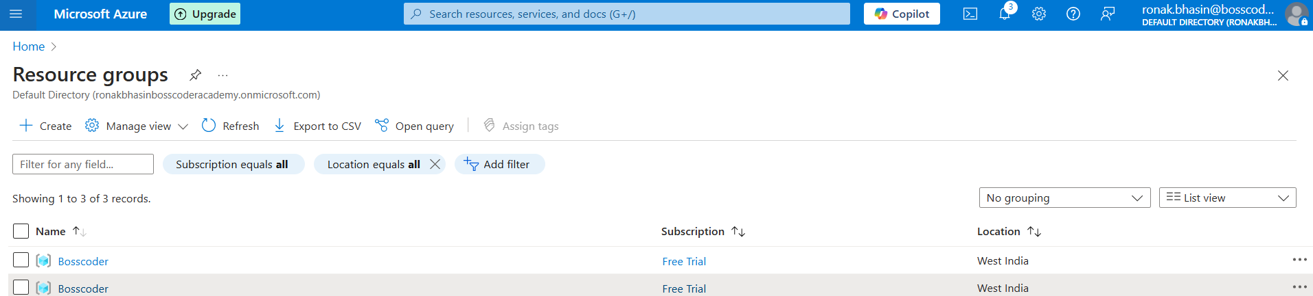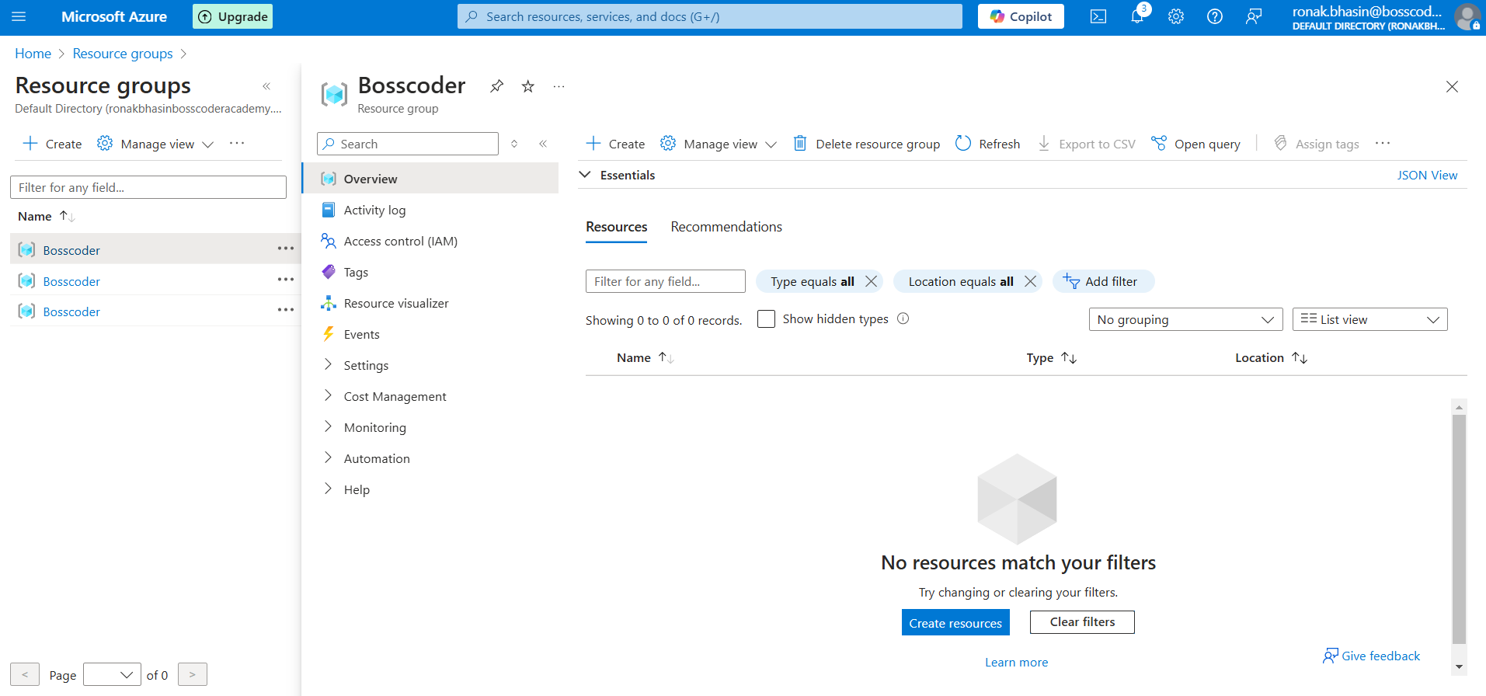
IAM: Users, Groups, Roles & Policies in Azure Active Directory (Azure AD):
Azure Active Directory (Azure AD) is Microsoft's cloud-based identity and access management (IAM) service. It helps organizations manage user identities and control access to resources.
Users in Azure AD:
A User in Azure AD represents an individual who can access Azure resources. Users can be employees, external users (B2B), or service accounts.
Types of Users:
- Cloud-only Users: Created and managed in Azure AD. No dependency on on-premises Active Directory.
- Synced Users: Synchronized from an on-premises Active Directory using Azure AD Connect.
- Guest Users (B2B Collaboration): External users from other domains who are invited to access resources (e.g., partners, vendors).
- Service Principal: Used by applications to access Azure resources.
Creating a User in Azure AD (Portal):
Step 1: Go to Azure Portal → Azure AD, here you will get various options where you can create Users, Roles as well as Tenant also.
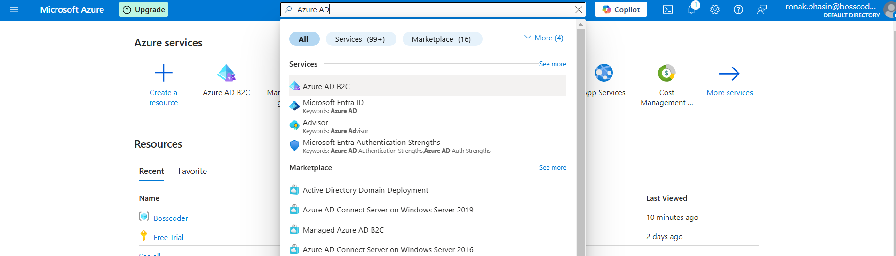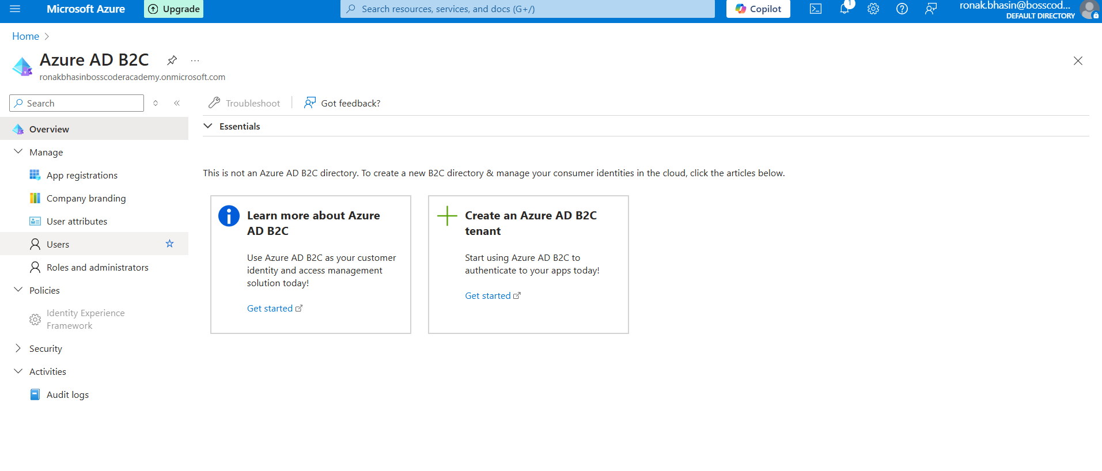
Step 2: Here, you will see the list of Users, but if you want to create a New User go to New User, click on Create new user if you want to create or click on Invite User, if you want to add an existing user.
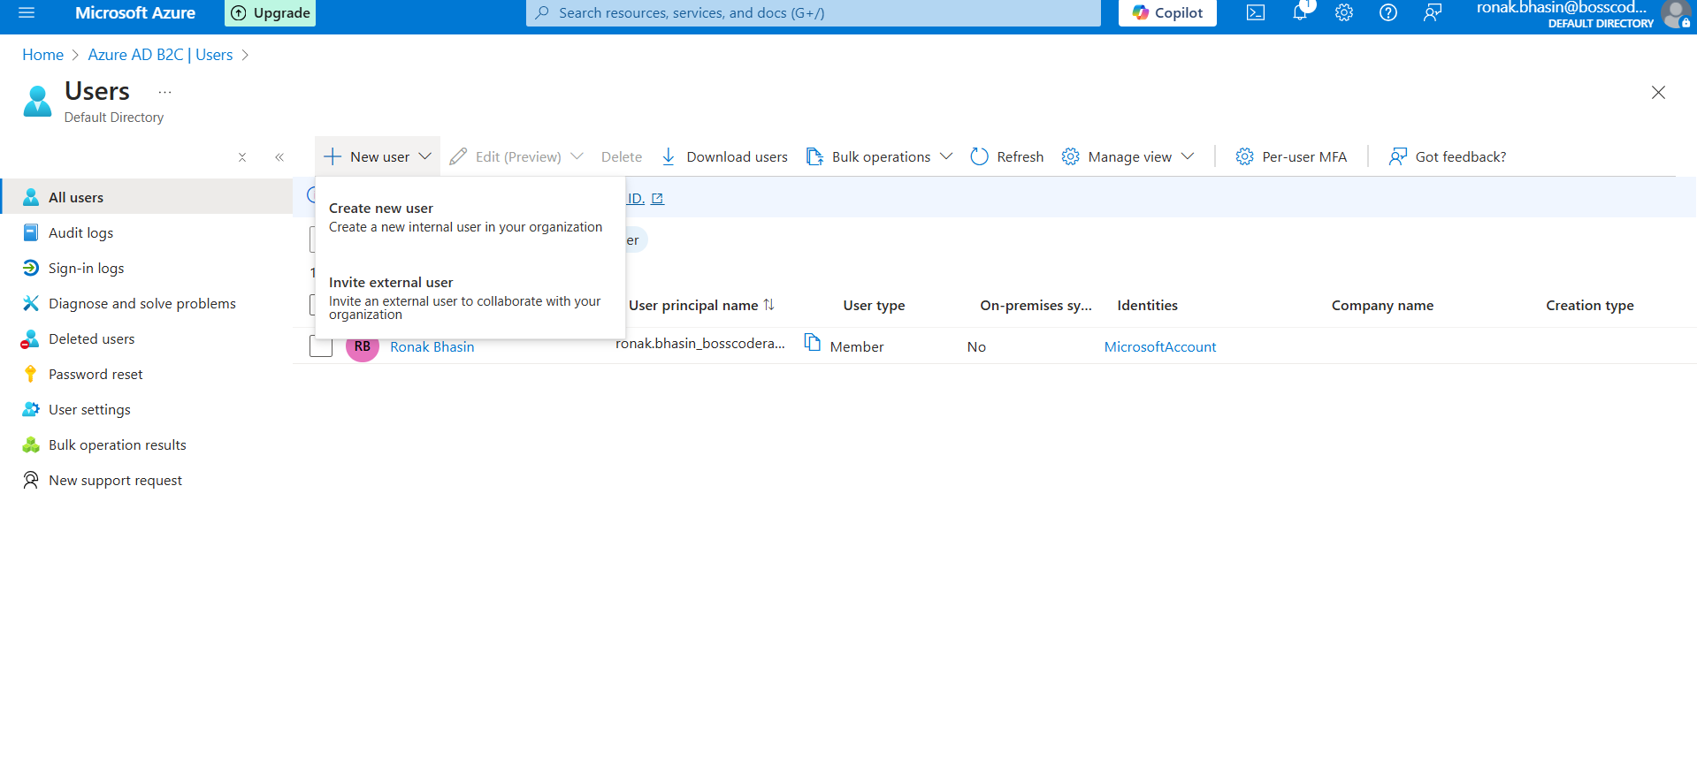
Step 3: Enter details like name, username, and password or generate it automatically by the option provided and then click on Review and Create, then the User is created and you can check the User in the Users list.
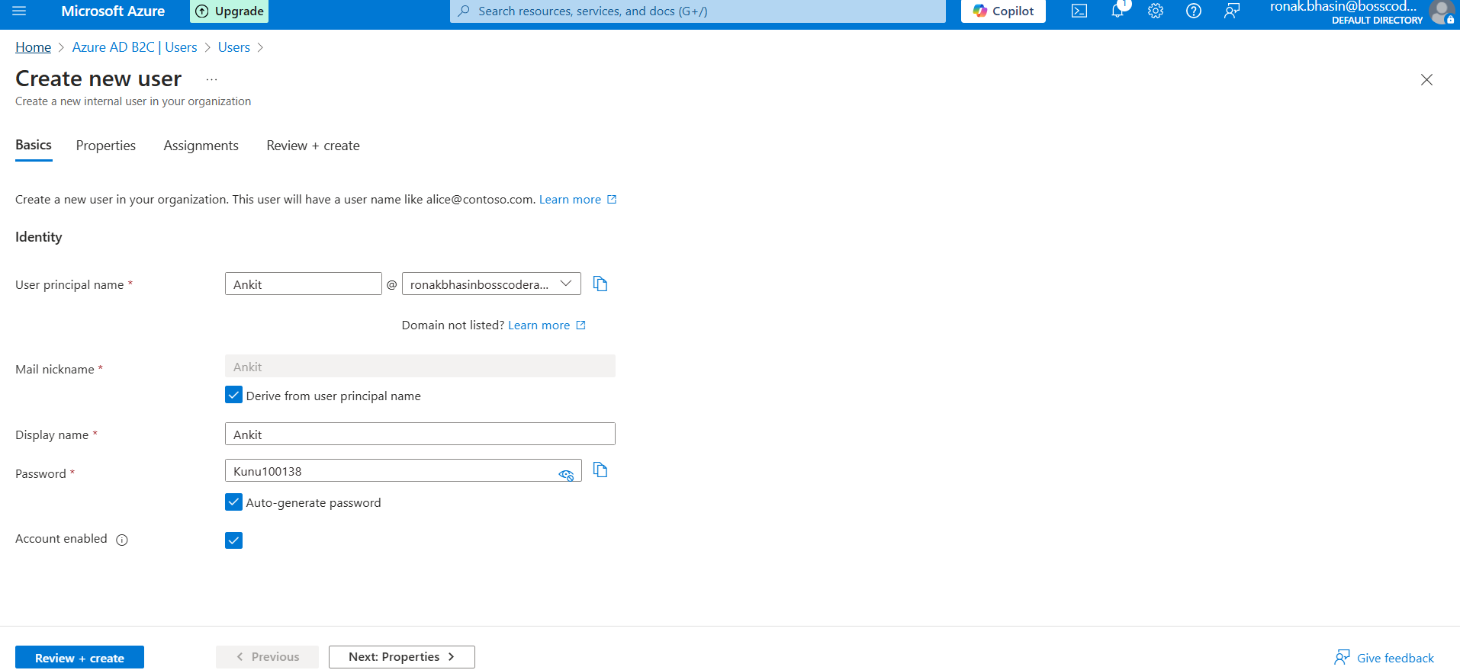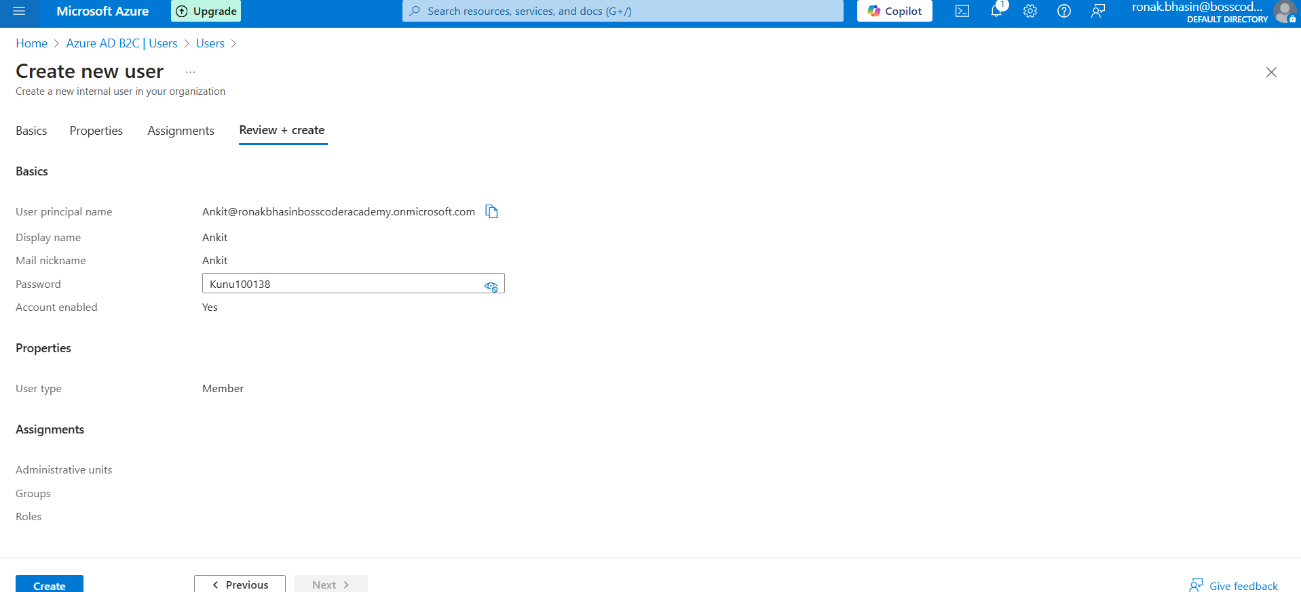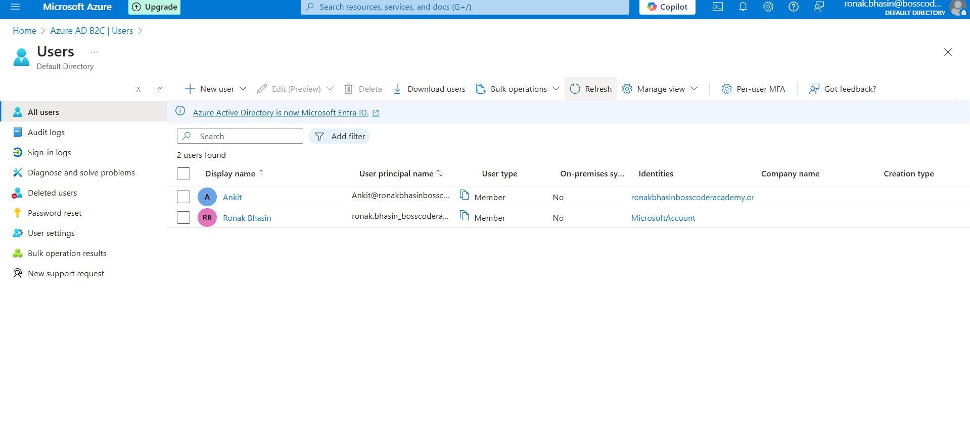
Groups in Azure AD:
Groups in Azure AD allow administrators to organize users and manage permissions collectively.
Types of Groups:
- Security Groups:
- Used to control access to resources (e.g., assign permissions to apps, VMs, databases).
- Can contain users, devices, and other groups.
- Microsoft 365 Groups (Formerly Office 365 Groups):
- Provides collaboration features (e.g., Teams, SharePoint, Outlook).
- Includes a shared mailbox, calendar, and files.
Group Membership Types:
- Assigned: Users are manually added or removed.
- Dynamic: Membership is based on rules (e.g., users in a specific department automatically join).
- Device-based: Contains Azure-registered devices.
Steps to Create a Group:
Step 1: Go to Azure Portal → Groups → New group.
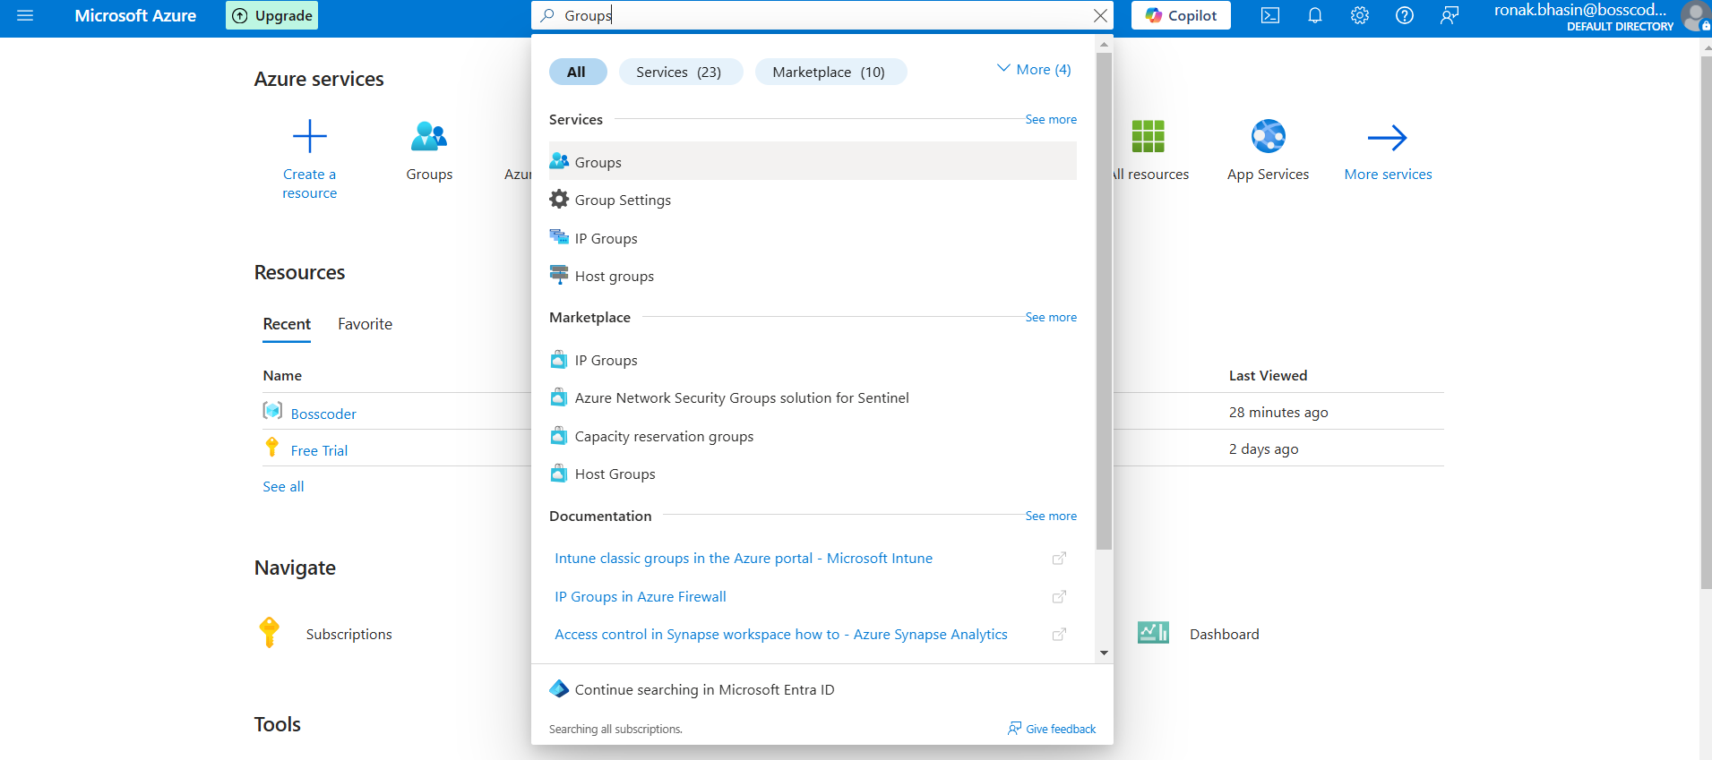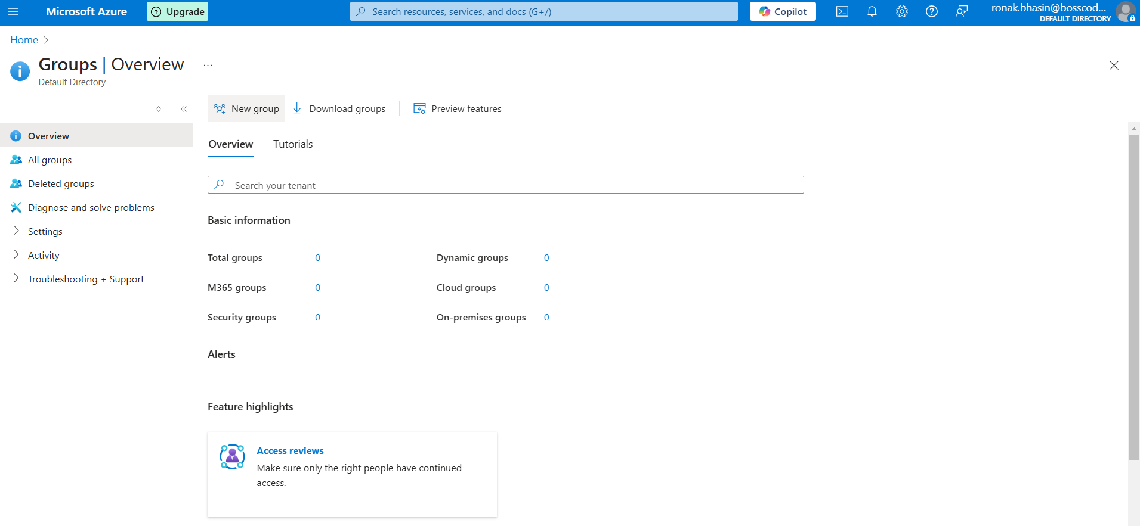
Step 2: Select Group Type (Security or Microsoft 365) then, assign a name, description, and membership type.
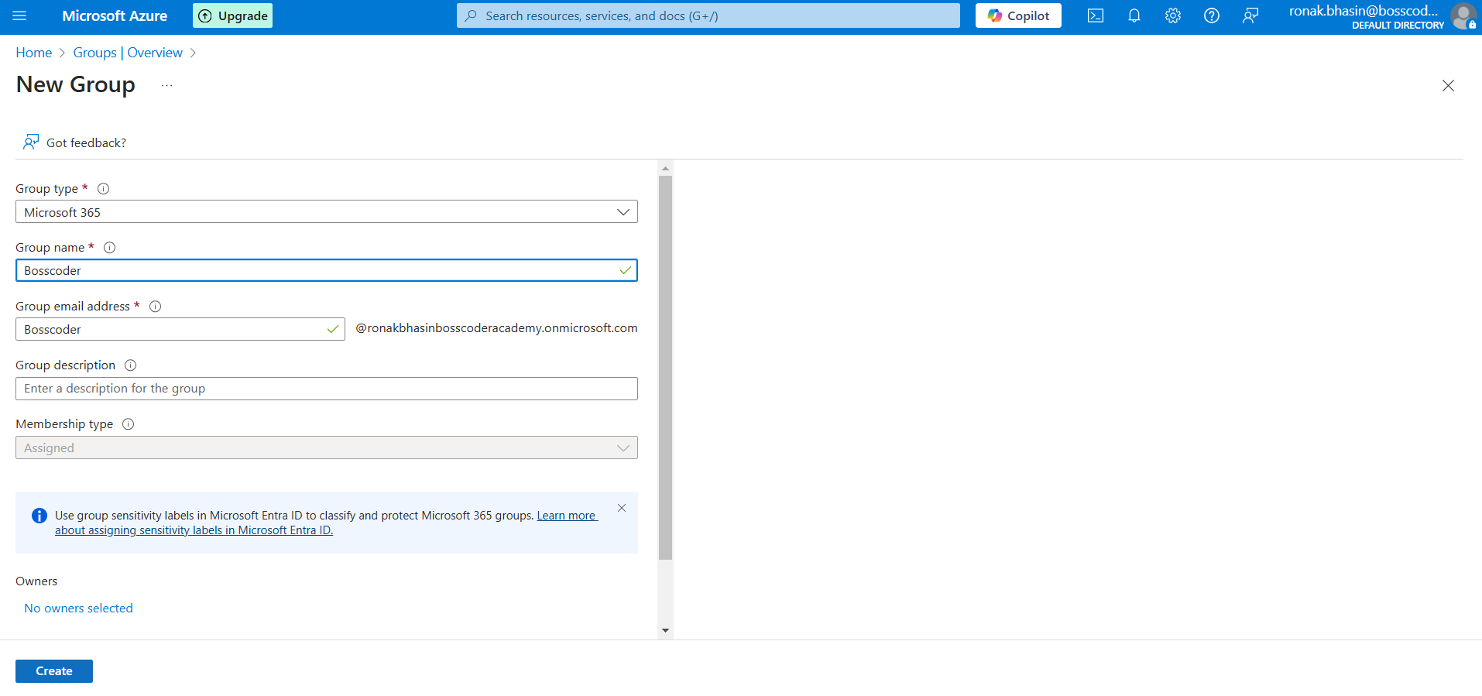
Step 3: Then, you can go to Groups and then Add Members.
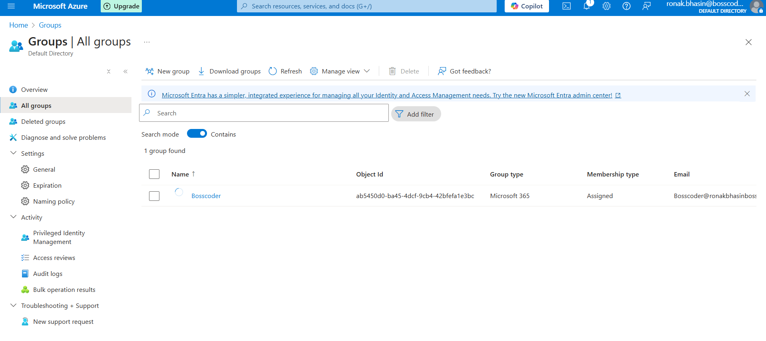
Roles in Azure AD:
Roles define what actions a user or group can perform on Azure resources.
Types of Roles:
- Azure AD Built-in Roles:
- Global Administrator: Full access to Azure AD (highest privilege).
- User Administrator: Manages users and groups but cannot assign admin roles.
- Application Administrator: Manages app registrations and permissions.
- Billing Administrator: Manages billing-related tasks.
- Azure RBAC (Role-Based Access Control) Roles:
- Owner: Full control over an Azure resource (create, delete, assign roles).
- Contributor: Can manage resources but cannot assign roles.
- Reader: Read-only access to resources.
- Custom Roles: Created by administrators for specific needs.
Steps for Assigning Roles to Users/Groups:
Step 1: Go to Azure Portal → Azure AD → Roles and Administrators.
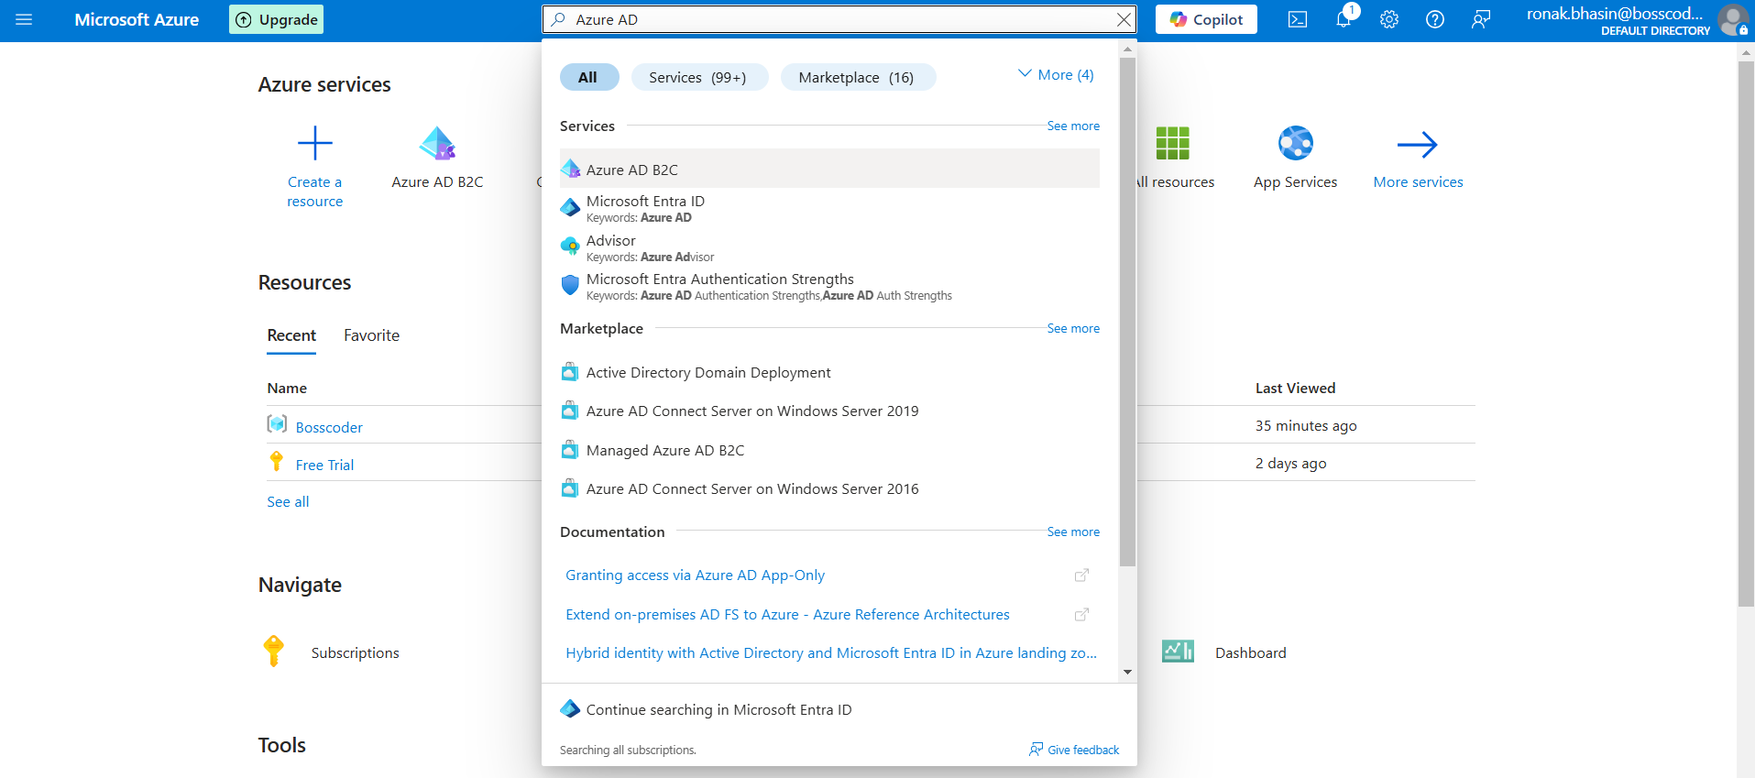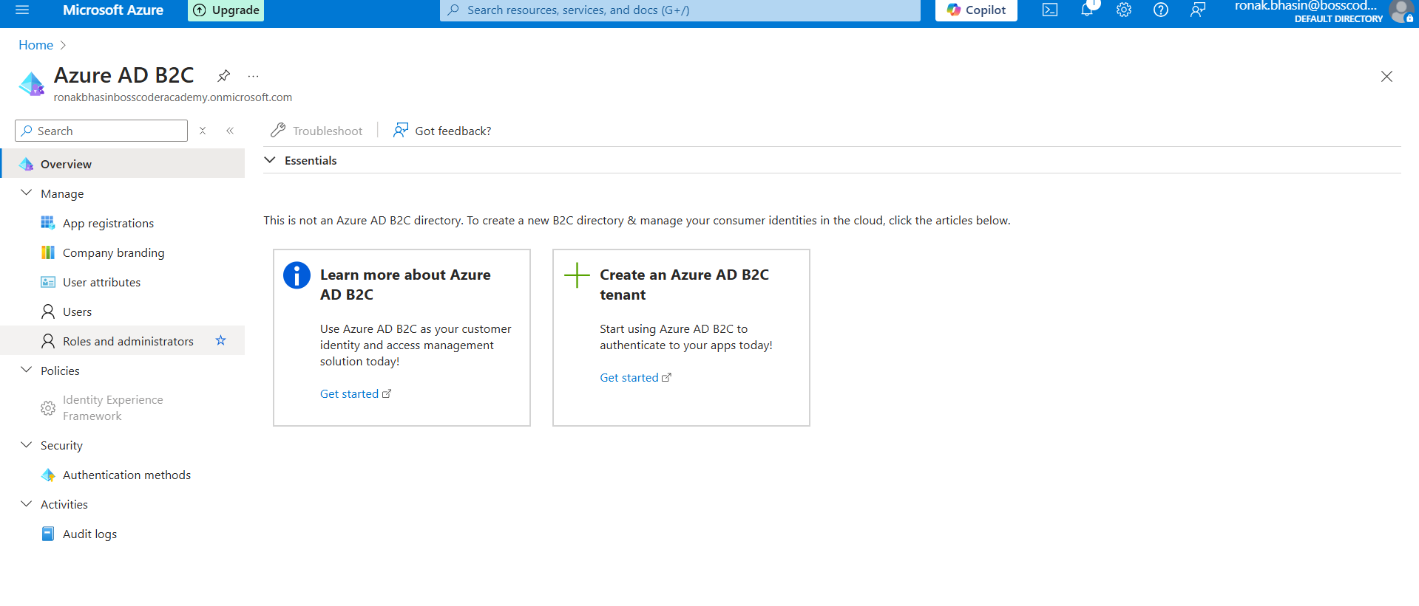
NOTE: You will get to know about your current Role here.
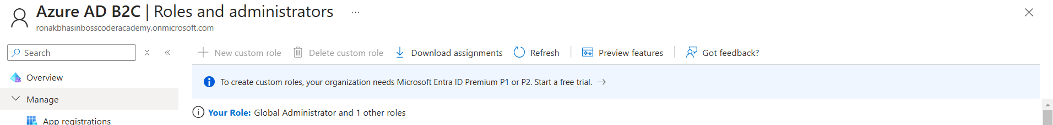
Step 2: Now, if you have a paid version, you can create a Custom role for any User by clicking on Create Custom Role by Choosing a role (e.g., Global Administrator) then,
- Click Assign, then select a user or group.
- Click OK to confirm.
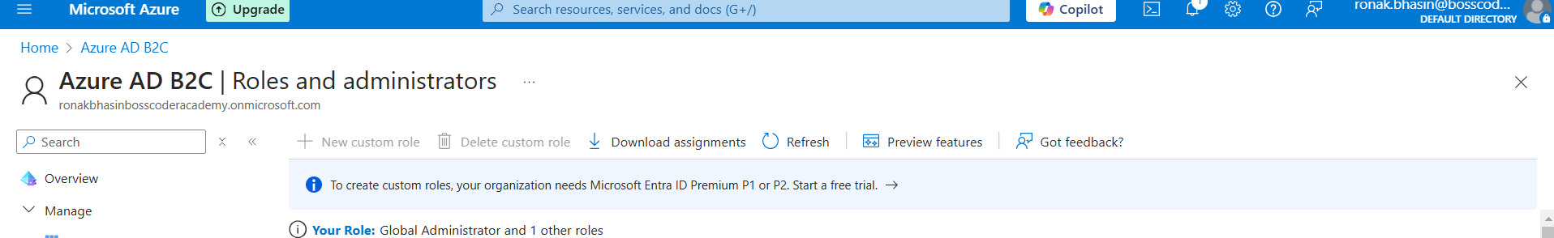
Policies in Azure AD:
Policies in Azure AD define security and access rules for users, groups, and devices.
Types of Policies:
1. Conditional Access Policies:
- Enforce conditions for user access (e.g., require MFA, block login from unknown locations).
- Example: "Require MFA for users accessing Azure from outside the corporate network."
2. Password Policies:
- Define password complexity and expiration rules.
- Example: "Require passwords to be at least 8 characters long and changed every 90 days."
3. Identity Protection Policies:
- Detects suspicious sign-ins and compromised accounts.
- Automatically blocks risky sign-ins or prompts for additional verification.
4. Access Reviews:
- Periodic review of user access to resources.
- Ensures least privilege access.
Steps for Conditional Access Policy:
Step 1: Sign in to Azure Portal → Go to Azure AD → Security → Conditional Access.
Step 2: Create Policy → Click New policy, enter a name.
Step 3: Assign Users/Groups → Select users, groups, or roles to apply/exclude.
Step 4: Set Conditions (Optional) → Define conditions like sign-in risk, device platform, locations.
Step 5: Configure Access Controls → Choose Block access or Grant access (e.g., Require MFA, compliant device).
Step 6: Session Controls (Optional) → Set sign-in frequency or session persistence.
Enable & Save → Start in Report-only mode, test, then enable.
Related Blogs

